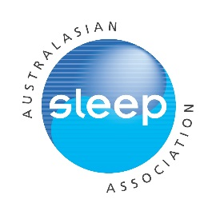
Philips/ASA Sleep Research Grant
Applicant name:
Contact Details: Email: Phone:
ASA Membership number: Year of initial membership:
Current institution:
Title of proposed project:

Note: All applications must be submitted online
This template may be used to prepare the application before submitting online.
Submission instructions:
In addition to completing the online application, you will need to submit a copy of your CV and a completed and signed proof of early career status form. Both documents will need to be in PDF format

Details to include in your CV (as appropriate):
- Name and contact details
- Education/training (including year of completion of postgraduate degree or equivalent)
- Appointments/positions: present and past
- Awards and honours
- Previous grants
- Brief summary of research: current and completed
- Any significant career disruptions (if relevant)
- Any other relevant information
- Publications and presentations

Applications will be judged on:
1) Scientific merit (50%)
2) Significance, innovation, and impact (25%)
3) Track record relative to opportunity (25%)

Length of ASA membership may also be taken into consideration.

Only full applications with all requested materials submitted prior to the closing date will be considered.

Brief description of the project in non-specialised language (200 word maximum):

Research Proposal

- Research questions/aims and hypotheses (250 words max):
- Methodology (including statistical analysis as appropriate) (250 words max):
- Brief description of the research environment and feasibility of completing the project within the time frame (250 words max):
- Potential impact of the research (250 words max):

References (500words max):

Brief budget with justification including description of how funds will be used (include other sources of funding support if applicable) (250words max):

